**Brooklyn torah gazette**

**For parshas Re’eh 5779**

Volume 3, Issue 51 (Whole Number 148) 30 Menachem Av 5779/ Aug. 30, 2019

**Printed L’illuy nishmas Nechama bas R’ Noach, a”h**

For a free subscription, please forward your request to [***keren18@juno.com***](mailto:keren18@juno.com)

**On Becoming an**

**American Citizen**

**By** [**Rabbi YY Rubinstein**](https://www.jewishpress.com/author/rabbi-yy-rubinstein/)

-

[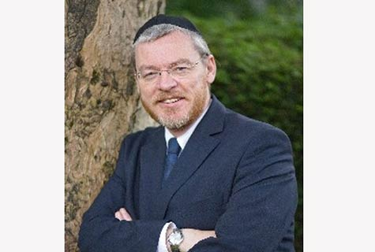](https://www.jewishpress.com/wp-content/uploads/2015/07/Rubinstein-073115.jpg)

Just a few days ago, on Thursday, August 8, I stood in a U.S. courtroom alongside 99 other people and repeated the Oath of Allegiance. I absolutely and entirely renounced and abjured all allegiance and fidelity to any foreign prince, potentate, state or sovereignty.

The fellow beside me held a card with the oath in his hands. He smiled at me weakly and asked in a heavy Spanish accent if I spoke “Good English.” I answered that I did. He quickly asked me to explain what “Sovereignty” meant. I dug deeply into my memory of schoolboy Spanish and suggested “Junta.”

Juan smiled happily and then asked his second question. “What does “potentate” mean?” Now it was my turn to smile weakly. Actually, I wasn’t 100% sure and decided to use the Spanish word for Leader, which is “Lider”! Actually, the Spanish for Potentate should have been easy to remember, it’s “Potentado.”

The Judge entered the courtroom and Juan, I and everyone else raised our right hands and firmly and solemnly declared that we were done with any old Juntas and, frankly, we’d completely had it with those Potentados too.

We heard the Judge’s own family story and how his grandfather arrived from Italy to Ellis Island with nothing but a knapsack and the clothes on his back. His father qualified as a pilot and fought in Korea, which led to a career as an airline pilot upon his return home. His Honor produced quite a laugh when he explained that he never dreamed he would end up as a judge, and that actually his parents most earnest wish was that their son keep himself “out” of courts.

The climax of the speech was filled with sincere love and passion for the United States. He declared that this was the greatest country in the world and that whatever a person’s origins or beliefs, they were now equal citizens with every other American citizen. He solemnly assured us that with hard work (and keeping out of courts from now on) it was still possible to fulfill the American dream and emulate his family’s journey.

I didn’t avail myself of the opportunity, as we were invited to do, to register myself to vote just then.

As much as I enjoyed and applauded his Honor’s speech, I think I would have to write a dissenting opinion, at least on part of it.

My dissent would be based on a belief that the America the Judge so loves and so many Americans still do, has changed and is changing.

I will be honest and declare that as a Jew my natural inclination is towards Maimonides’ dictum of always following the middle path. Extremes are anathema to Judaism. Whichever of the two main parties I would choose, would see me planting my feet firmly in the middle ground. I would hope that whether I look to my right or my left I would see the majority of people, Republican and Democrat, happy to move toward the same place.

I think that given a lifetime’s concern for the less well off, I would naturally see myself, as so many other American Jews have done for generations, standing slightly to the left of that middle ground and registering as a Democrat.

The developments of the past few weeks changed that “inevitable” conclusion and affiliation.

You see, I came here from the UK. The capture of the once noble Labour party (sister party of America’s Democratic Party) by extreme Left-wingers and anti-Semites is now complete. A disturbingly high percentage of them come from Britain’s Muslim community where anti-Semitism is off the scale.

The identical process emanating from the same extreme Left-Muslim alliance, the so-called “Red-Green alliance,” has infected the Democrats.

And it is telling how very little it takes to tilt the balance and change a party.

Consider the case of the “Squad.” Readers of this paper will be well aware of Ilhan Omar’s anti-Semitism. They will also have heard Jewish Democrat’s scoffing at the very thought that this quartet represents the *real*Democratic party.

Actually, they should really be renamed America’s “Gang of Four.” These were the four scapegoats who were blamed by the Chinese Communist Party for the worst excesses of the Cultural Revolution. The party needed scapegoats to divert attention from the fact that they were responsible for the evil that was unleashed.

When Nancy Pelosi tried to reprimand Omar and pass a motion condemning anti-Semitism, the new gang of four threatened to have Congressmen and women thrown out by leftist activists. Pelosi and the party folded.

Now after two of the gang of four were refused permission to fly to Israel (actually they announced they were going to “Palestine”) to slander the Jewish State, Democrats are plotting to find a way to “punish” Israel. The Party has rallied around their racist extremists. By so doing, *it*is responsible for the evil of anti-Semitism they unleashed. *It* now plan to condemn and punish Jews for not welcoming Jew-haters with open arms.

Elizabeth Warren and Bernie Sanders led the charge against Israel, with Pelosi, Kamala Harris, Joe Biden and many more joining in.

I have still not made up my mind what to put on my voter registration. I want to hope and vote for the middle ground and those who reject extremism. Inevitably, that means that I will no longer be joining today’s Democratic Party.

*Reprinted from the August 23, 2019 email of The Jewish Press.*

**The Shmuz onParshas Re’eh**

**Life: The School of Growth**

**By Rabbi Bentzion Shafier**

**Founder of TheShmuz.com**

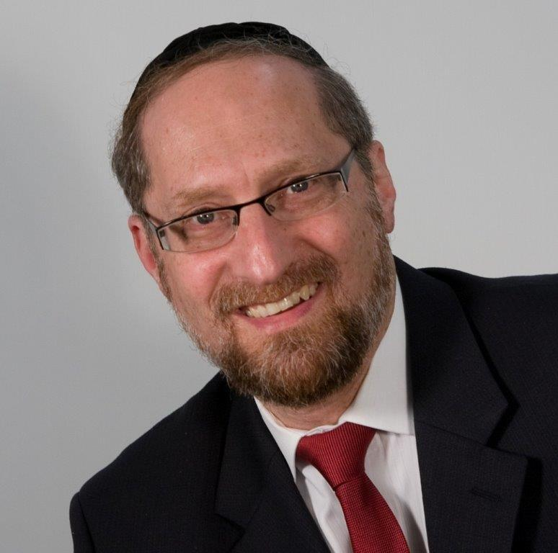

*“See I have placed in front of you today a blessing and a curse. The blessing: if you will listen to all of the mitzvahs of HASHEM your G-d as I have commanded you today…”* — Devarim 11:21

There are two paths in front of you…

In these *posukim*, the Torah sets out two divergent paths. One path leads to ultimate success and blessing, and the other to devastation and curses. If you follow in the ways of HASHEM, you will be richly rewarded. You will look back at your years of sacrifice with enormous joy and satisfaction, saying to yourself, “Whatever price I paid was so worth it. I am now being compensated beyond anything I could have imagined.”

On the other hand, if you don’t follow the Torah’s ways, there will come a time when you will deeply regret your mistake and you will look back and say, “Woe is me! How could I have been so foolish? How could I have chosen so poorly?”

**A Moshol for Life**

The *Daas Zakainim* brings light to this concept with a *moshol*. He says it is comparable to a crossroads. One road begins as a difficult thorny trail, then it opens up, and the rest of the way is clear. The other path begins as a smooth passageway, but ends in a thicket of thorns.

An old man sits at the crossroads and warns the passersby, “Be careful. This road begins smoothly, but ends up all thorns. Rather choose the other road. Even though it begins as a difficult path, it opens up and will carry you well.”

Anyone who listens to the man will work at the outset of his journey, but will travel in peace the rest of the way; whereas anyone who ignores the advice of the old man will get caught in the thorns for rest of his passage.

The *Daas Zakainim* explains that this is what the Torah is telling us. If a man sins and follows his inclinations, he will find comfort in this world, but when he dies, he will go to *Gehennom*, which is all thorns. However, if one works in this world and labors in Torah study and *mitzvahs*, he will merit the World to Come, which is all goodness, joy, and happiness.

**What Do We Gain from the Parable?**

This *Daas Zakainim* is difficult to understand because the meanings of the *posukim* seem self-evident – serve HASHEM and you will receive blessing; violate the *mitzvahs* and you will be cursed. It doesn’t seem that he is adding much to our understanding with this *moshol*. If the point is that punishment and reward aren’t in this world, but rather in the Next, that concept doesn’t need a parable. Simply state, “the Torah is referring to the World to Come.” What point is the *Daas Zakainim* trying to bring home to us with this *moshol*?

To understand this, we need a different perspective of life.

**Progressive Weight Training**

A rather *yeshivishe* fellow went to a power-lifting gym to learn how to work out. As a kid, he had little experience with sports and was clearly out of his element. Recognizing this, the coach showed him various exercises and worked closely with him. One day, this fellow was overheard saying, “That coach, I don’t know what’s with him. Every time I get the exercise right, he goes and adds more weight to the bar. What’s wrong with him?”

The point this fellow missed was that **progressive weight training** is all about increasing the load. The goal of the activity is to coax the body to grow. By gradually increasing the work load, the body is called upon to respond. The work should never be easy. The nature of the activity is to incrementally increase the demand placed on the body, thereby causing it to grow.

This is a good parable because in life we are put into many situations. If a person doesn’t understand why he is on this planet, he will have many questions. Why is life so difficult? Why is it that when I finally get things under control, a whole new set of circumstances arises that sets everything out of kilter? Why can’t life just be easy?

The point that he is missing is the very purpose of life. HASHEM put us on this planet to grow. Many of the challenges and situations are given to us specifically for that reason. It isn’t by accident, and it isn’t because HASHEM doesn’t pay attention. Quite the opposite, these situations were hand-designed to demand from us. They are catalysts to change who we are.

In weight training, the movement of the bar isn’t the significant part; the demand on the body is. So too in life, the situations I face are far less significant than my reactions to them. Who I become is a result of my attitude and the way I handle my challenges.

When a person understands this perspective, then life itself makes sense. If not, then the situations in life seem arbitrary and unfair.

**The Answer: Why the**

**Daas Zakainim Used a Moshol**

The answer to the *Daas Zakainim* seems to be that this *moshol* defines our path in life. The road that we are being asked to take isn’t easy. It isn’t laden with roses and doesn’t smell like lilacs. It has thorns. A life properly led will have moments of doubt, pain, and confusion. That doesn’t mean that we are on the wrong path. Quite the opposite, if life is going too smoothly, it’s a bad sign. Since the purpose of life is to grow, we need the challenges of life to help us reach our potential. If the road is too level, that is likely a sign that we have chosen the wrong path.

HASHEM wants us to enjoy our stay on this planet, but there is a plan and a purpose to it all. If a person lives his life in accordance with the Torah, he finds deep satisfaction, an inner sense of peace and tranquility, and true *simcha*. But it isn’t a walk in the park. There is much work along the way.

There are trials, travails, and circumstances that demand growth. If a person responds appropriately, he finds a sense of inner peace because he is in synch with his purpose in life. That sense of balance is an indicator that he is on the right path, and the work that he puts in on that path will bring him to true joy, happiness, and elation in this world, and much more so in the World to Come.

*Reprinted from this week’s website on TheShmuz.com This is an excerpt from the*[*Shmuz on the Parsha book*](https://theshmuz.com/product/shmuz-on-the-parsha-book/)*.*

**Understanding that No Evil**

**Can Come from Above**

**From the Talks of the Lubavitcher Rebbe**

**Rabbi Menachem Mendel Schneerson, Zt”l**

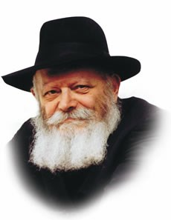

We find ourselves now in the special weeks during which the "Seven Haftorah's of Consolation" are read. This week we read the third of the seven, taken from the Book of Isaiah.

The Avudraham, a Torah scholar who lived in the medieval times, explains that these seven haftorahs form a dialogue between the Jewish people and G-d.

In the first Haftorah, G-d tells the Prophets to console His people over the destruction: "Comfort, O comfort, My people."

The response of the Jewish nation in the second Haftorah is, "But Zion said, 'the Eternal has forsaken me.'"

The consolation of the prophets is not sufficient; the Jews want to be consoled by G-d Himself.

In the third Haftorah, the Prophets convey this message to G-d: "O you afflicted, tossed with tempest, and not comforted" -- the comfort we offer Israel is not enough.

In the fourth Haftorah, G-d responds by saying, "I, even I, am He Who comforts you" -- I have heard your demand and I Myself will console you. Indeed, the fifth and sixth Haftorahs begin with the words, "Sing, O barren one, you that did not bear," and "Arise and illumine, for your light is come."

In the seventh and final Haftorah, the Jewish people delight in G-d's comfort: "I will greatly rejoice in the Eternal, my soul shall be joyful in my G-d."

This explanation, however, presents a problem.

For Omniscient G-d certainly knew in advance that the Jewish people would not be satisfied with His Prophets' comforting.

Why, then, didn't G-d simply console them Himself, instead of waiting until they cried out, "The Eternal has forsaken me"?

In truth, it was necessary for the Jewish people to reveal their desire to be consoled by G-d alone, for it expressed their realization that the destruction and exile were not visited upon them as a punishment, but rather, conceal a G-dly benevolence and exalted kindness.

Chasidic philosophy explains that "no evil can come from Above."

Hidden within the disastrous destruction of the Temple is an enormous good that could not have come down into this world in a revealed and open manner; this good is of such magnitude that it must be veiled in tragedy. "G-d tries those whom He loves" -- G-d's most intense and inner love is expressed in His admonishments.

In order for the great blessings hidden within to be uncovered, one must first understand that his suffering is not a curse, G-d forbid.

When a person views his troubles as punishment from Above, he cannot perceive the good that they contain. Accepting one's suffering with joy leads to the inner good being revealed, revealed in a way that even our fleshly eyes can discern.

G-d wanted the request for comfort to come from His children, to demonstrate that they understood that the destruction contained a higher good, one that He alone would show them.

"I, even I, am He Who comforts you" -- a consolation that will reach its culmination in the Final Redemption and the building of the Third Temple, speedily in our day.

*Reprinted from the Parashat Re’ei 5754/1994 edition of L’Chaim Weekly (Issue #275), a publication of the Lubavitch Youth Organization in Brooklyn, NY.*

**Rav Avigdor Miller on the**

**Source of Emotional Problems**

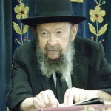

**QUESTION:** Are emotional problems considered *yissurim*?

**ANSWER:** Certainly. But it depends how those emotional problems originated. Most emotional problems are the result of wrong *middos*. When people are נוקם ונוטר, they can’t forget what somebody once said to them, it boils in them and makes them sick. It’s only people who can forget, they can overlook what has been done to them, who can remain healthy. Just ignore it.

Like the *gemara* (Sanhedrin 7a) says: טוביה דשמע ואדיש - How happy is man who hears people saying things and he pays no attention, חלפוה בישתי מאה - a hundred evils will pass him by.

You get excited that your mother-in-law said this or that?! You're a fool; just forget about it! She didn’t know what she was talking about. Your wife said something to you? Forget about it - your wife doesn’t know what she’s talking about. Your husband said something - ignore it; he doesn’t know what he’s talking about. Pay no attention.

So, “How happy is the man who hears and ignores.” Just ignore it. Because when a person doesn’t ignore it, it eats him up. And he gets emotional problems. So therefore a person has to think sensibly - think about Hakodosh Boruch Hu, how many good things He does for you in this world.

Think about how lucky you are to have two good eyes - most of you have two good eyes. You have something to eat. You have a bed to sleep in at night. You have so many good things in this life, so try to enjoy them.

ראה בטוב השם - “Look at the goodness of Hashem,” and then your character will often straighten out and most of your emotional problems will become nothing.

*Reprinted from the August 16, 2019 email of Toras Avigdor, based on Tape #E-12.*

**Rabbi Berel Wein on**

**Parashat Re’eh**

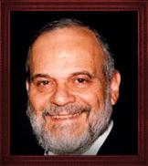

The Torah presents us with a seemingly simple and uncomplicated choice in this week's reading - the choice between life and death. And the Torah deems it necessary to instruct us to choose life. It certainly seems at first glance to be a very superfluous instruction, for the instinct to preserve our lives for as long as possible is one of the basic drives of human beings. An equal part of our nature is that we are shortsighted and give in today foolishly against our own interests and our own life force itself.

There is no other explanation for why alcohol, tobacco and recreational drugs should exist in our society, allowing for hundreds of thousands of lives every year to be summarily wasted. Choosing life has many nuances attached to it. People who are determined to enjoy pleasures of the flesh, to satisfy wanton desires, and to pursue temporary pleasures regardless of the long-term costs and consequences also think that they are somehow choosing life and its pleasures.

One of the great catchphrases that exist in our current society is quality of life. Like all catchphrases and currently socially acceptable mantras and mottos there is no way to define this term. No one can measure accurately what life means to any individual person and quality of life is certainly not given to measurement by any objective standards.

The whole tragedy of eugenics and biological selection that was so common in the 20th century is based upon the fact that somehow someone with superior intelligence can measure what quality of life means to a given individual. And, if those given individuals do not measure up to those elitist standards, then this becomes preferable to life. The twentieth century is littered with millions of corpses who were victims of such false and murderous thoughts and policies.

To put it bluntly, the Torah is very much pro-life. It is pro-life before we are born, while we are alive, and after the physical body has returned to the dust from which it was created. That is why the Torah emphasizes that we should choose life and not give in to the specious theories and quality-of-life fictions and conveniences. Our mere existence as human beings presents us with difficult choices at every stage of our lives. It is never quite as easy as the verse in the Torah may indicate at first glance.

Because life is not always convenient or even pleasant, it requires sacrifice, postponement of pleasure and a long view of the consequences of our actions and behavior. As such, choices for life are always made in a gray area and are not generally as black and white as we would wish them to be.

The Torah comes to help guide us through this unclear and muddied situation that we call society. It comes to establish the rules by which we would always be wise enough to choose life and avoid the pitfalls of fads, desires and foolishness that can only lead to the loss of life, qualitatively and quantitatively.

*Reprinted from this week’s website of Rabbiwein.com*

**The Power of One’s Actions**

**By Rabbi Eli J. Mansour**

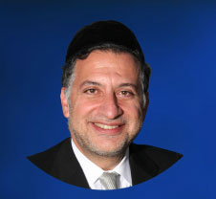

Moshe Rabbenu begins Parashat Re'eh by exhorting Benei Yisrael, "Look, I have presented before you today a blessing and a curse." Many commentators noted the grammatical shift in this verse from the singular to plural tense. The word "Re'eh" ("Look") is written in the singular form, whereas "Lifneichem" ("before you") is in the plural. How can we explain this sudden shift within the same verse?

The Keli Yakar (Torah commentary by Rabbi Shlomo Efrayim on Luntchitz, Poland-Bohemia, 1550-1619) suggests an explanation based on the Sages' comment that a person should always view himself and the world as perfectly balanced on the scale of merit.

Each person should act as though he has precisely as much merit to his account as demerits, such that a single good deed would tilt the scales in his favor, whereas a single transgression would tip the scales against him.  Similarly, a person should conduct his life on the assumption that the world at large has a perfectly balanced account, and therefore any action he performs could tip the scales in either direction.

What this means is that a person's conduct, every action a Jew performs, has a profound impact upon the entire world, upon all of mankind. A Jew must never think that his religious life is a strictly personal matter between him and G-d, and is not the business of anybody else.

The famous analogy isdrawn to a person who rides a ship and digs a hole in the floor of his private cabin. The captain knocks on his door and orders him to stop digging, but he refuses, claiming that he digs the hole in his private cabin, for which he paid full price. What he does in his private quarters, he argues, is no business of anybody else. Of course, he is gravely mistaken; the hole he digs in his floor has repercussions for everybody else on the ship, which will sink as a result of that hole.

Similarly, how a person conducts himself, the Mitzvot he performs and the transgressions he commits, have a profound impact on his community and on the entire world. Before a person chooses how to act, he must take into account not only the effects of his behavior on his own personal account with G-d, but its ramifications for mankind, and for countless generations to come.

According to the Keli Yakar, this is precisely the message Moshe sought to convey in the opening verse of Parashat Re'eh. He turns to each individual and admonishes, "Re'eh" – look and understand that I present these warnings "Lifneichem" – to you, in the plural, to the entire nation, and to the entire world. Every person must understand that his actions affect all people, and not only his own life.

Adam and Chava committed the grave sin of partaking from the forbidden tree, as a result of which God cursed all mankind for all eternity. Every time a person must work and toil to earn a living, he is bearing the effects of Adam's sin; and every time a woman suffers through childbirth, she experiences the impact of the act Chava committed millennia ago.

Conversely, good deeds have the power to bring blessing and reward to people around the globe, for countless generations in the future. Avraham Avinu refused to accept a gift from the ill-begotten fortune of the king of Sedom, and he swore that he would take not even a shoe-strap.

The Sages teach that in reward for this single remark, Avraham's descendants – centuries later – were given the Mitzva of Tefillin, the obligation to wrap the straps of Tefillin around their heads and arms.  Every time a Jew dons Tefillin and accrues merit, he is reaping the benefits of this single gesture of Avraham Avinu.

One must never undermine the power and importance of even the seemingly "small" Mitzvot.  A person should seize every Mitzva opportunity and never let it pass him by, for he never knows how he might be literally saving the world, or how many people he might be helping, through the performance of that single good deed.

*Reprinted from this week’s website of the Edmund J. Safra Synagogue in Brooklyn, NY.*

**An Interview with the**

**Yetzer Hara about Daf Yomi**

**By Rabbi Moshe Meir Weiss**

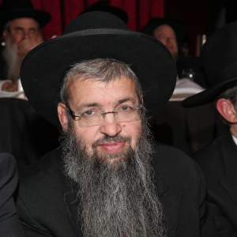

We interrupt our series on tefilah for this timely interview with the Yeitzer HaRa.

A few days ago, as I was strolling down Thirteenth Avenue, I saw a harried Yeitzer HaRa walking with a troubled look on his face. As you know, I always try to grab the Yeitzer HaRa for a quick interview in order to gather some vital tidbits on how to battle his diabolical schemes. Therefore, upon spotting him, I quickly ran after him and asked him why he looked so frantic. He answered:

**Yeitzer HaRa [YH]:** They just opened up for the general public available seating for the grand Siyum HaShas at MetLife Stadium this **coming January 1, 2020.**

**Rabbi Weiss [RW]:** So, why is that making you so upset? Isn’t it just a get rich scheme for the Agudas Yisroel?

**YH:**Are you out of your mind? Do you know how many thousands of people get inspired from this event and are turned on to learn the Daf Yomi?

**RW:**Awww, come on! You think that because of a chilly January 1st stadium appearance people will embark on a seven and a half year, every day commitment?

**YH**: You underestimate the spiritual intoxication of being together with thousands of people who have reached a life’s dream of finishing Shas.

**RW**: Why do you care so much anyway?

**YH:**You know, the Gemora in Baba Basra reveals that I wear three hats. I’m the Yeitzer HaRa, the satan, and the malach hamaves. In my guise as malach hamaves, I’m known as Sama-eil (spelled Samach, Mem, Alef, Lammed). This is an acronym for Siyum Masechta Ayn Laasos. I try at all costs not to let a person finish a masechta. Finishing Shas is my greatest nemesis. It is the truest antidote against the Yeitzer HaRa and the surest potion for life.

**RW**: So what are you worried about? You know that most people don’t have the stamina for an every day, seven and a half year commitment.

**YH**: Maybe that was true in the olden days but now with the availability of ArtScroll and aids as such Kol Halashon, TorahAnytime.com, and Dial-a-Daf, more people are able to jump on the Daf Yomi bandwagon.

**RW**: Even so, if you look through the windows of Daf Yomi shiurim, there are people dozing off and staring in space having lost their train of thought, not able to follow the intricate shakla v’tarya of the Gemora.

**YH**: It’s true, but once they make an attempt to study a daf, even if they don’t grasp it they will be allowed to master that daf in the Great Academy of the Yeshiva shel Maalah.

**RW**: Don’t many people feel that Daf Yomi is just superficial and is not really Torah learning?

**YH**: People are not so naïve anymore. They have more confidence in the opinions of the Chortkova Rebbe, Rav Meir Shapiro, and the Chofetz Chaim to name but a few who felt that Daf Yomi is the right learning formula for Klal Yisroel.

**RW**: Aren’t there many people who feel that they simply can’t get a real understanding of the Gemora when learning so rapidly. Wouldn’t they rather learn a lot slower and with more comprehension?

**YH:**What I’m seeing is that people are embarking on the Daf Yomi with a five-cycle plan. They figure the first time they’re getting their feet wet, they’ll understand it even more the second time around, and really become proficient when they get to the third time. I also think that people are really galvanized to unite with the global brotherhood of Daf Yomi. I hate when they practice such achdus!

**RW**: At least you don’t have to worry about the women. They probably have no interest to attend such a ‘male’ celebration.

**YH**: Oy! Are you wrong! The women know the Gemora in Berachos that states that they have a share in the nitzchius, the eternity of Torah partly because of their husband’s learning. To my chagrin, they really feel a connection to the Daf Yomi hysteria.

**RW**: At least there will be thousands of people there just because it’s the IN place to be. They’re coming with the attitude that it’s like a concert.

**YH**: Even those people, I’m afraid, get incredible inspiration from saying Shema Yisroel and Amein, Ye’hei Shmei rabba with 90,000 of their brethren. Just answering Amein with such a massive crowd to v’chaim tovim aleinu v’al kol Yisroel makes a severe dent in my efforts. Not to mention that they feast their eyes on so many Gedolei Yisroel! It’s a real lose-lose proposition for me.

**RW:**At least when they bring their children, all it will accomplish is that they won’t be able to pay attention the next day in school.

**YH**: Boy! Are you wrong! When children see that 90,000 people come to give honor to those who learn Daf Yomi, it makes an indelible impression on their young minds, one that will remain for a lifetime.

**RW**: As always, I thank you for your time. As you know, I’m not sympathetic to your cause. I cheer on all of these people that they will make this the cycle that they too will connect with the 2,711 blat of Shas. It’s a game changer for their life, the life of their family, for this world and the Next. I hope everyone who reads this will grab a Gemora Berachos and start the Daf Yomi with me for the new cycle.

*Reprinted from the Parshas Eikev 5779 email of the Jewish VUES.*

**A Lone and Destitute Jewish Woman Gets a Jewish Burial**

**By Ashira Weiss**

A convivial funeral-home owner, a retired insurance investigator and a Massachusetts rabbi teamed up to bring an abandoned body to Jewish burial this morning. A bevy of volunteers joined the two-week long search that brought this seven-month ordeal to a close.

On November 14, 2018, at the age of sixty-two, **Nancie Shapiro** died of a heart attack at the MetroWest Medical Center in Framingham, Massachusetts. When no one came to claim her body, the hospital contacted **Peter Stefan** at the Graham, Putnam & Mahoney Funeral Parlors in Worcester and he agreed to take custody.

“When they have someone who has nobody, they call me because they know I’ll take them,” Peter says in an interview with *Lubavitch.com*. He says he deals with about sixty abandoned bodies a year. Asked why he does this when so many others won’t he says, “There’s no money in this, but we’re not talking about a bag of potatoes. There has to be a conscience here.”

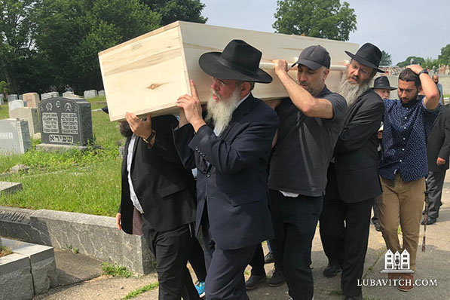

**Rabbi Yakov Lazaros and others bring Nancie Shapiro's remains to a Jewish burial in Everett, MA**

Until last year, Massachusetts law required a signature from next of kin to authorize a cremation. An act that Peter helped pushed for, passed in July 2018 and allowed a city’s Board of Health to approve cremation for any remains unclaimed after thirty days.

“But Jews aren’t cremated,” Peter says. “And with a name like Shapiro, I was pretty sure she was Jewish.” He hoped a relative would come forward, but “couldn’t find a soul,” so two weeks ago, on June 27, he went to the Framingham Board of Health and got 3-0 approval to cremate Nancie’s remains.

Peter was still not comfortable with doing something that could be against her religion, so when a reporter came to talk to him about the Board of Health’s decision, he enlisted his help in getting the story out. “I hoped that the publicity would shake the tree and some leaves would start falling,” he says.

Rabbi **Yakov Lazaros** has led [Congregation Bais Chabad](https://www.chabadframingham.com/) of Framingham for forty years and has conducted many funerals over that time. When one of his congregants showed him the story in the Metrowest Daily News, Rabbi Yakov wanted to get involved.

“Cremation is absolutely forbidden by Jewish law. In the book of Genesis, G-d told Adam that he came from the earth and must return to earth. I wanted to save a Jewish woman from cremation.”

Framingham doesn’t have it’s own *chevra kadisha* (Jewish burial society) so he reached out to the one in Boston. An official there offered to find a donor for a burial plot and give her a Jewish burial.

But first Rabbi Yakov had to establish that Nancie was indeed Jewish.

He contacted Peter who promised to use any sway he had to get information and then the rabbi went down to the hospital records department to glean more. Nancie hadn’t indicated a religious preference and had only been admitted as an outpatient, so information was scarce.

After hours of research, including a meeting with the hospital’s executive director and a very reticent social worker who had handled Nancie’s case, Lazaros learned that Nancie had a daughter. But as a mental health patient, her information was protected under HIPPA privacy laws.

Meanwhile, Peter discovered that Nancie’s mother was named **Sandra Shapiro** née **Baranski**. He called the reporter at the *Daily News* who’d first reported on the story and asked him to run another article with these new pieces of information. If they could establish that Sandra was Jewish, they would know that Nancie was too, because according to Jewish law, a person’s Jewish identity is passed down through the mother.

Last Thursday, a woman named **Patty** called Rabbi Yakov. “She was an insurance investigator so she knew how to find people.” Patty had seen the article and was moved by it. She wanted to know how she could help. Her investigations brought her to discover **Fred Shapiro**, Nancie’s father, and though he had passed away years ago, Patty found contact information for his second wife, **Arden** and her son.

“I tried calling Arden all Friday until Shabbat was about to begin,” Rabbi Yakov says, but it was to no avail. He tried again on Saturday night after Shabbat was over and this time Arden answered. “She didn’t have anything conclusive, but felt very strongly that Sandra had indeed been Jewish.” Rabbi Yakov asked her to look for any documents that would attest to this. It wasn’t a document, but she gave him a lead when she said that the Shapiro family is buried at the New Montefiore Cemetery on Long Island.

A quick Google search brought him to the cemetery website where he entered Sandra Shapiro’s name in the locator tool and hit the jackpot. A call to the cemetery confirmed that Fred Shapiro had paid for the burial of Sandra Shapiro née Baranski. Proof of Jewish burial confirmed that Sandra, and thereby, Nancie were Jewish.

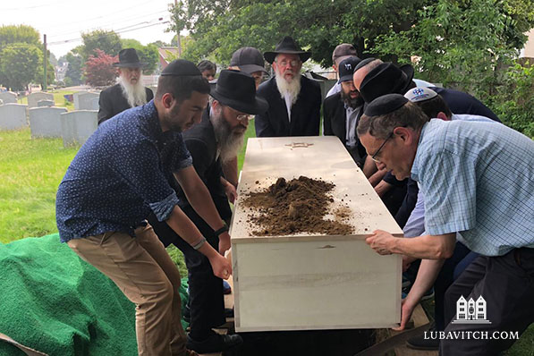

Henry had found a cemetery in Everett, just outside Boston, whose caretaker, **Steve Schneider** was willing to donate a plot and grave marker for Nancie. Peter offered to pay for a kosher casket, which he had ordered from Providence, Rhode Island with the help of **Peter Golov**, a Jewish funeral director at Graham, Putnam & Mahoney. He also paid for Jewish burial shrouds that he had brought in from Boston.

The funeral was set for this morning. Now all they needed was a minyan.

When Rabbi Yakov arrived at the Rabbi Isaac Elchonon Cemetery, an hour from his home, he was greeted by Peter Golov, members of the Boston *chevra kadisha* and eight Chabad rabbis from around the Boston area. “It’s unusual to be able to fulfill the special mitzvah of burying someone who has no one to take care of his or her burial (a *mes mitzvah*). Everyone wanted to take part in the mitzvah,” Rabbi Yakov says.

Rabbi Yakov shared a few words as members of the small group, who had each taken time out of their day to travel here, carried the casket to the designated plot and laid to rest the remains of a woman unknown to all of them.

“After a life of abuse and suffering, Nancie died alone and destitute, yet her funeral and the lead up to it have been a testament of unconditional kindness.” Rabbi Yakov also asked her forgiveness for not bringing her the respectful interment she deserved sooner.

Peter was relieved to see the story come to a satisfactory conclusion, but he was not surprised. “There are people in the Jewish community that go out of their way for another and when a situation like this arises, they step up to the plate.”

In one more act of kindness, Rabbi **Levi Fogelman**, of Chabad of nearby [Natick](https://www.chabad.org/centers/default_cdo/aid/117630/jewish/Chabad-Center-of-Natick.htm?gclid=CjwKCAjw36DpBRAYEiwAmVVDMJTciOJzrf7um6QkcJoFiU2uJsePH2Tmxd5uSvIG43wWI9zuUYww4BoCG94QAvD_BwE), who had been instrumental with Rabbi Yakov in establishing Nancie's Jewishness, pledged a plaque for Nancie on his center’s remembrance wall. Nancie’s name will be mentioned at the synagogue's *Yizkor* memorial service, when congregants will pray for her soul four times every year.

*Reprinted from the July 11, 2019 dispatch of Lubavitch.com*

**Thoughts that Count**

*Behold, I set before you this day a blessing and a curse* (Deut. 11:26)

There are two different kinds of "today" -- the "today" of blessing and the "today" of curse. Consideration of the present moment as an impetus for action can be either positive or negative: "If not now, when?" spurs a Jew on to do good, whereas "Eat and drink for tomorrow we die" leads him down the path of evil. *(Rabbi Chanoch Henich of Alexander)*

*You are the children of the L-rd your G-d* (Deut. 14:1)

Just as the child is drawn down from the brain of the father, so are the souls of the Jewish people drawn down from G-d's Supernal wisdom. However, the connection between the Jew and G-d is even loftier than that between an earthly father and son, for G-d's wisdom is not a separate entity from Him, but "He and His wisdom are one." *(Tanya)*

*You shall not shut your hand from your needy brother* (Deut. 15:7)

In Hebrew, the first letters of this verse spell out the word "Tehillim" -- Psalms. Reciting Psalms on behalf of a poor person is not enough; one must open his hand and give him material sustenance as well. *(Rabbi Yisrael of Ruzhin)*

*Reprinted from the Parashat Re’ei 5754/1994 edition of L’Chaim Weekly (Issue #329), a publication of the Lubavitch Youth Organization in Brooklyn, NY.*